**Exercise 1: Configuring a Basic Spring Application**

**Scenario:**

Your company is developing a web application for managing a library. You need to use the Spring Framework to handle the backend operations.

**Steps:**

1. **Set Up a Spring Project:**
   * Create a Maven project named **LibraryManagement**.
   * Add Spring Core dependencies in the **pom.xml** file.
2. **Configure the Application Context:**
   * Create an XML configuration file named **applicationContext.xml** in the **src/main/resources** directory.
   * Define beans for **BookService** and **BookRepository** in the XML file.
3. **Define Service and Repository Classes:**
   * Create a package **com.library.service** and add a class **BookService**.
   * Create a package **com.library.repository** and add a class **BookRepository**.
4. **Run the Application:**
   * Create a main class to load the Spring context and test the configuration.

Code:

package com.library.service;  
  
import com.library.repository.BookRepository;  
  
public class BookService {  
 private BookRepository bookRepository;  
  
  
 public void setBookRepository(BookRepository bookRepository) {  
 this.bookRepository = bookRepository;  
 }  
  
 public void getBook(int id) {  
 bookRepository.fetchBookById(id);  
 }  
}

package com.library.repository;  
  
public class BookRepository {  
 public String findBookById(int id) {  
 return "Book with ID: " + id;  
 }

}

package com.library;  
  
import com.library.service.BookService;  
import org.springframework.context.ApplicationContext;  
import org.springframework.context.support.ClassPathXmlApplicationContext;  
  
public class MainApp {  
 public static void main(String[] args) {  
  
 ApplicationContext context = new ClassPathXmlApplicationContext("applicationContext.xml");  
  
  
 BookService bookService = (BookService) context.getBean("bookService");  
 bookService.getBook(101);

}

}

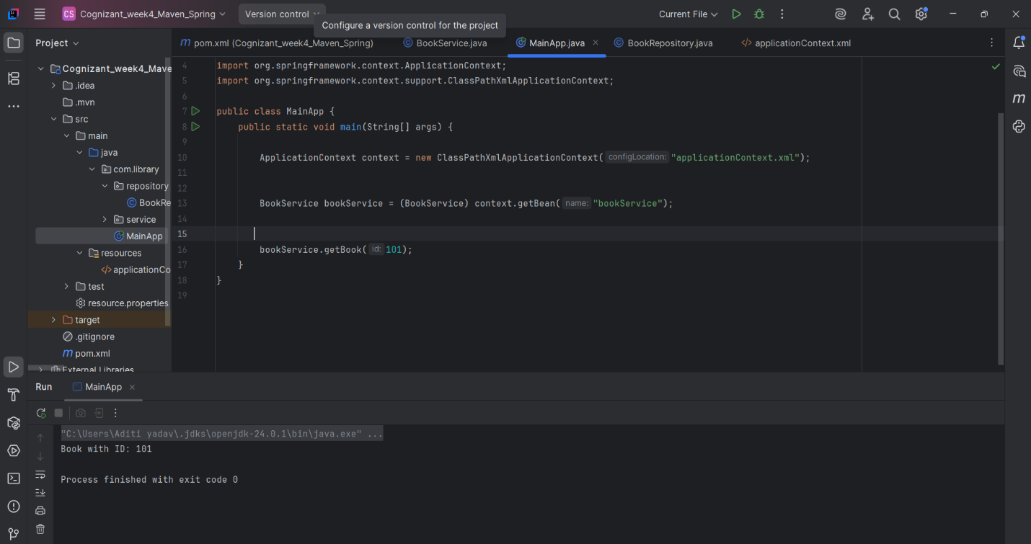

**Exercise 2: Implementing Dependency Injection**

**Scenario:**

In the library management application, you need to manage the dependencies between the BookService and BookRepository classes using Spring's IoC and DI.

**Steps:**

1. **Modify the XML Configuration:**
   * Update **applicationContext.xml** to wire **BookRepository** into **BookService**.
2. **Update the BookService Class:**
   * Ensure that **BookService** class has a setter method for **BookRepository**.
3. **Test the Configuration:**
   * Run the **LibraryManagementApplication** main class to verify the dependency injection.
4. <?xml version="1.0" encoding="UTF-8"?>  
   <beans xmlns="http://www.springframework.org/schema/beans"  
    xmlns:context="http://www.springframework.org/schema/context"  
    xmlns:aop="http://www.springframework.org/schema/aop"  
    xmlns:xsi="http://www.w3.org/2001/XMLSchema-instance"  
    xsi:schemaLocation="  
    http://www.springframework.org/schema/beans  
    http://www.springframework.org/schema/beans/spring-beans.xsd  
    http://www.springframework.org/schema/context  
    http://www.springframework.org/schema/context/spring-context.xsd  
    http://www.springframework.org/schema/aop  
    http://www.springframework.org/schema/aop/spring-aop.xsd">  
     
     
    <context:component-scan base-package="com.library" />  
     
     
    <bean id="bookService" class="com.library.service.BookService">  
    <property name="bookRepository" ref="bookRepository" />  
    </bean>  
     
     
    <bean id="bookRepository" class="com.library.repository.BookRepository" />

package com.library.repository;  
  
public class BookRepository {  
 public String findBookById(int id) {  
 return "Book with ID: " + id;  
 }  
  
 public void fetchBookById(int id) {  
 return "Book with ID: " + id;  
 }  
}

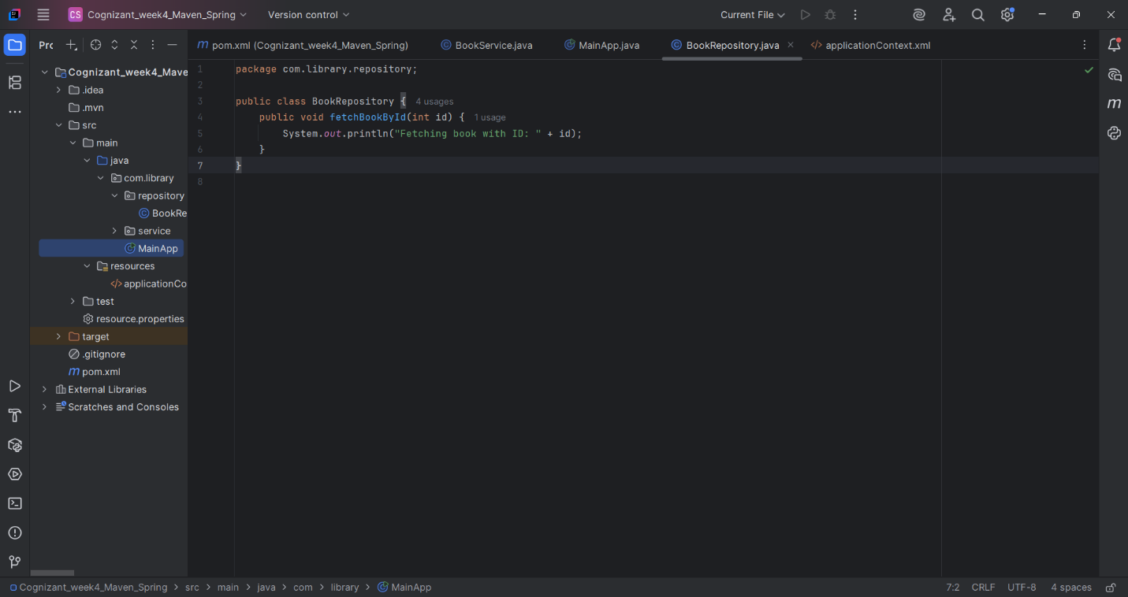

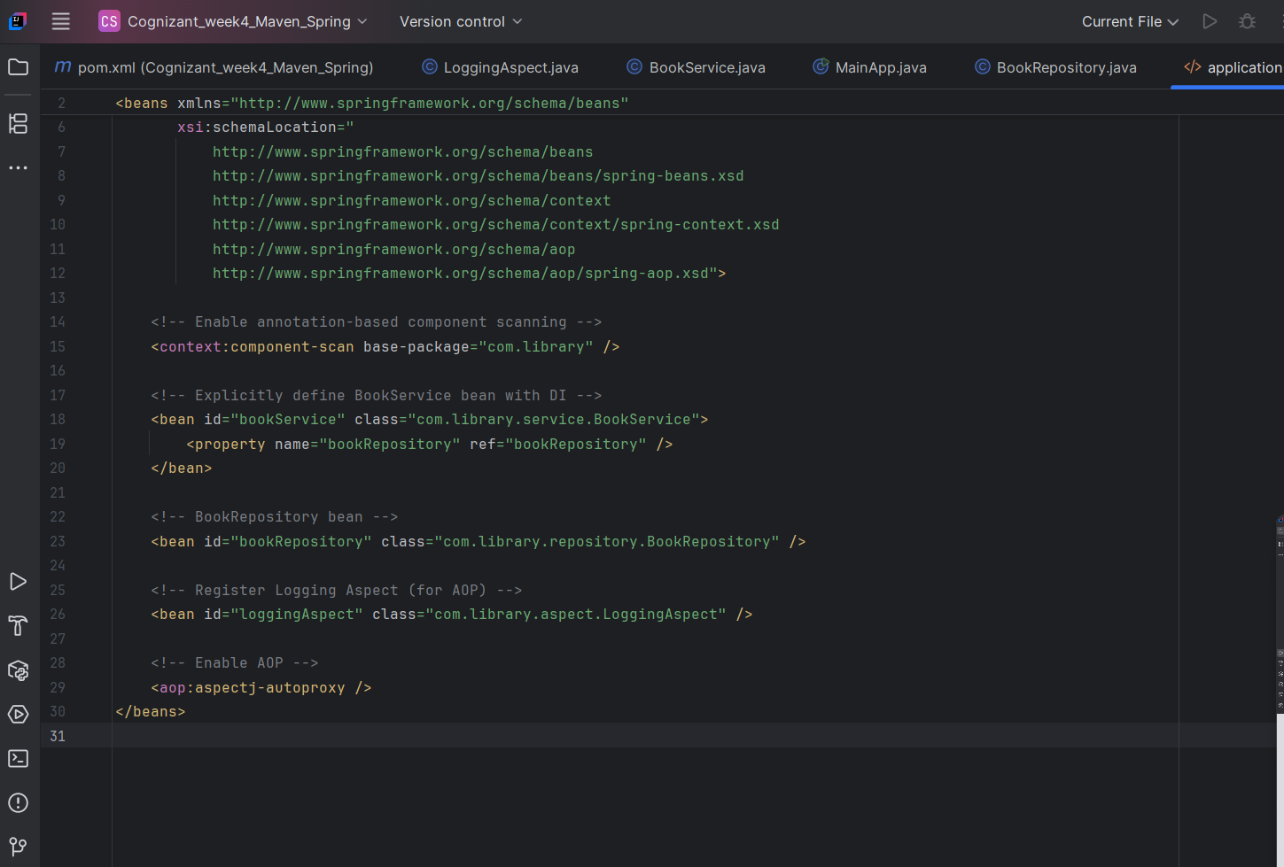

**Exercise 3: Implementing Logging with Spring AOP**

**Scenario:**

The library management application requires logging capabilities to track method execution times.

**Steps:**

1. **Add Spring AOP Dependency:**
   * Update **pom.xml** to include Spring AOP dependency.
2. **Create an Aspect for Logging:**
   * Create a package **com.library.aspect** and add a class **LoggingAspect** with a method to log execution times.
3. **Enable AspectJ Support:**
   * Update **applicationContext.xml** to enable **AspectJ** support and register the aspect.
4. **Test the Aspect:**
   * Run the **LibraryManagementApplication** main class and observe the console for log messages indicating method execution times.

Code:

package com.library.aspect;  
  
import org.aspectj.lang.ProceedingJoinPoint;  
import org.aspectj.lang.annotation.Around;  
import org.aspectj.lang.annotation.Aspect;  
  
@Aspect  
public class LoggingAspect {  
  
 @Around("execution(* com.library.service.*.*(..))")  
 public Object logExecutionTime(ProceedingJoinPoint joinPoint) throws Throwable {  
 long start = System.*currentTimeMillis*();  
  
 Object result = joinPoint.proceed(); // continue method execution  
  
 long end = System.*currentTimeMillis*();  
  
 System.*out*.println("[LOG] Method " + joinPoint.getSignature() +  
 " executed in " + (end - start) + " ms");  
  
 return result;  
 }  
}

<bean id="loggingAspect" class="com.library.aspect.LoggingAspect" />  
  
<aop:aspectj-autoproxy />

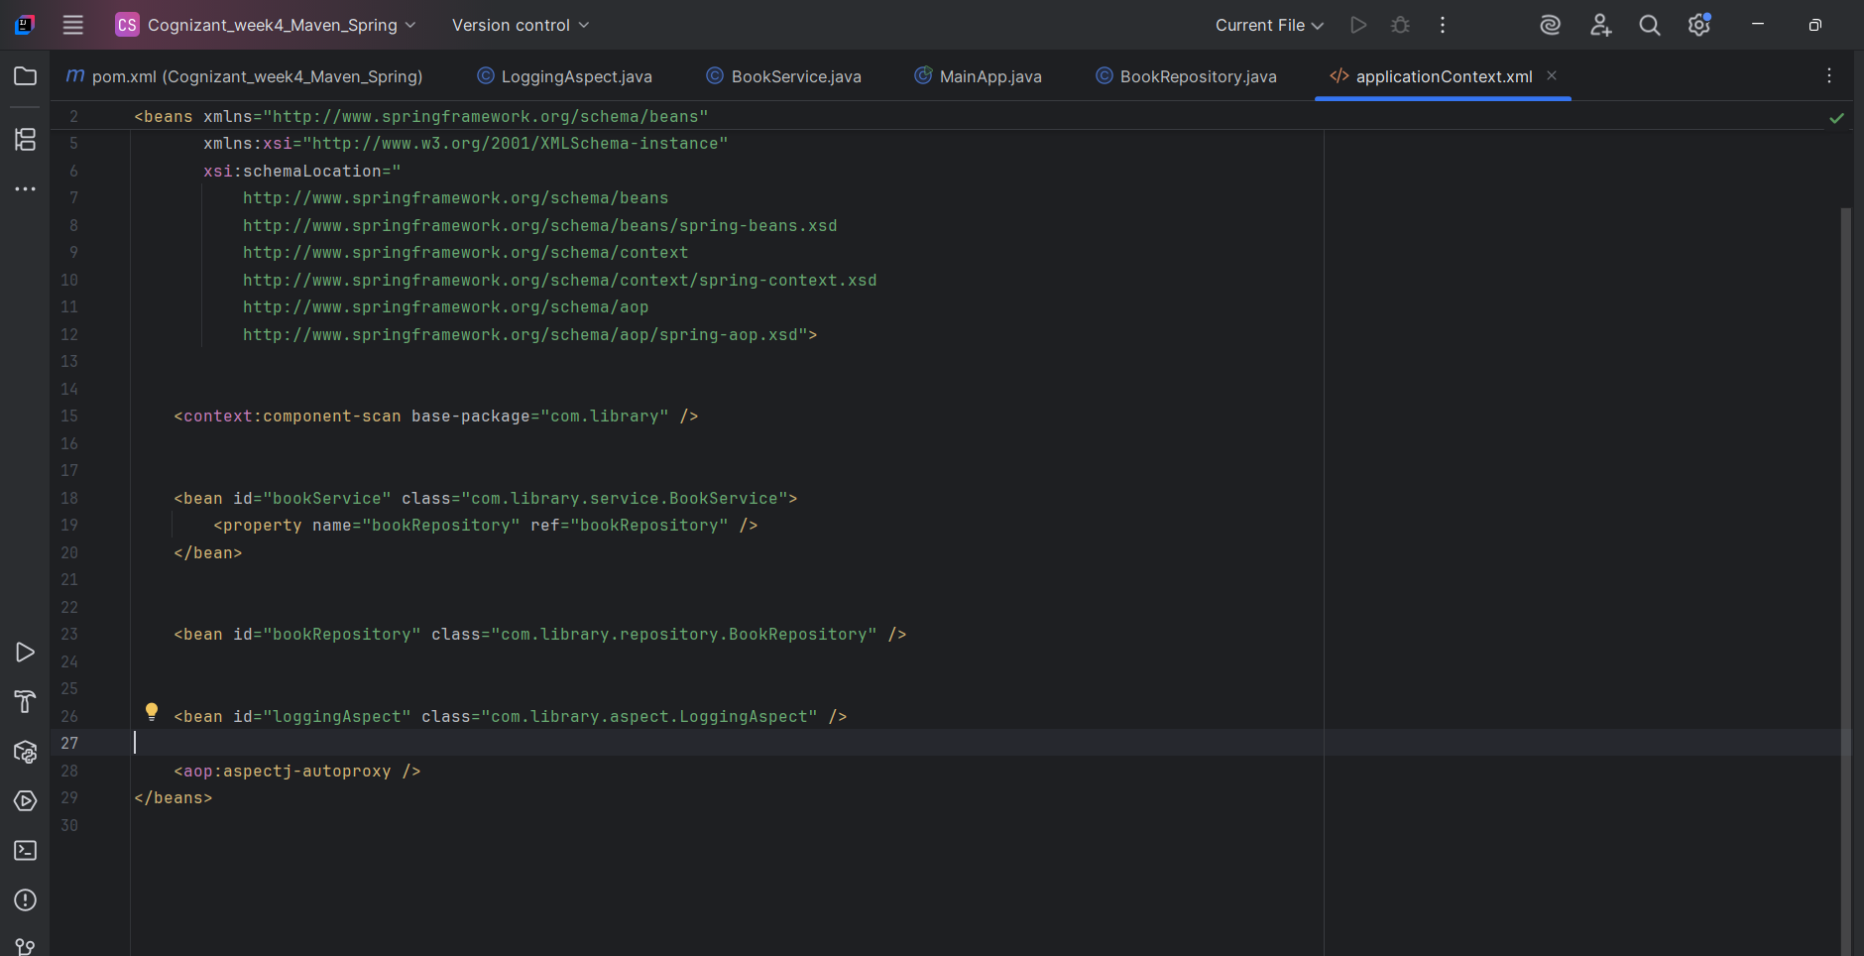

**Exercise 4: Creating and Configuring a Maven Project**

**Scenario:**

You need to set up a new Maven project for the library management application and add Spring dependencies.

**Steps:**

1. **Create a New Maven Project:**
   * Create a new Maven project named **LibraryManagement**.
2. **Add Spring Dependencies in pom.xml:**
   * Include dependencies for Spring Context, Spring AOP, and Spring WebMVC.
3. **Configure Maven Plugins:**
   * Configure the Maven Compiler Plugin for Java version 1.8 in the pom.xml file.

Code:

<build>  
 <plugins>  
 <plugin>  
 <groupId>org.apache.maven.plugins</groupId>  
 <artifactId>maven-compiler-plugin</artifactId>  
 <version>3.10.1</version>  
 <configuration>  
 <source>17</source>   
 <target>17</target>  
 </configuration>  
 </plugin>  
 </plugins>  
</build>

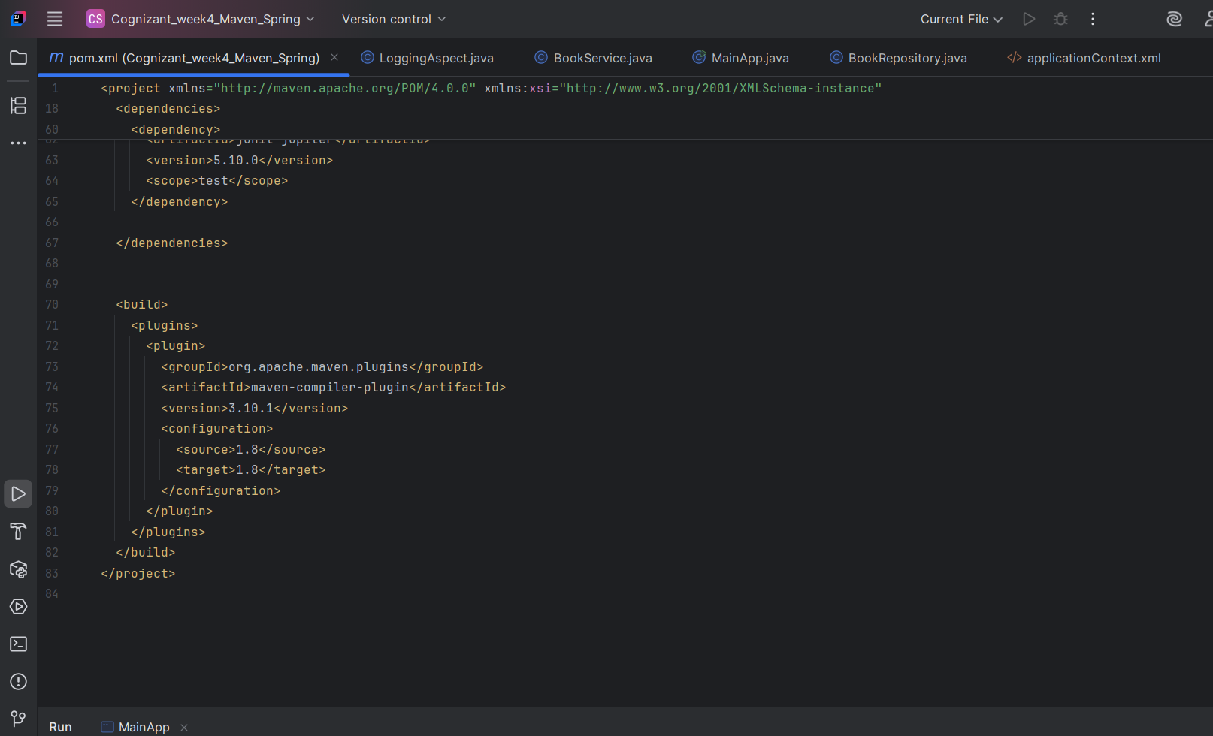

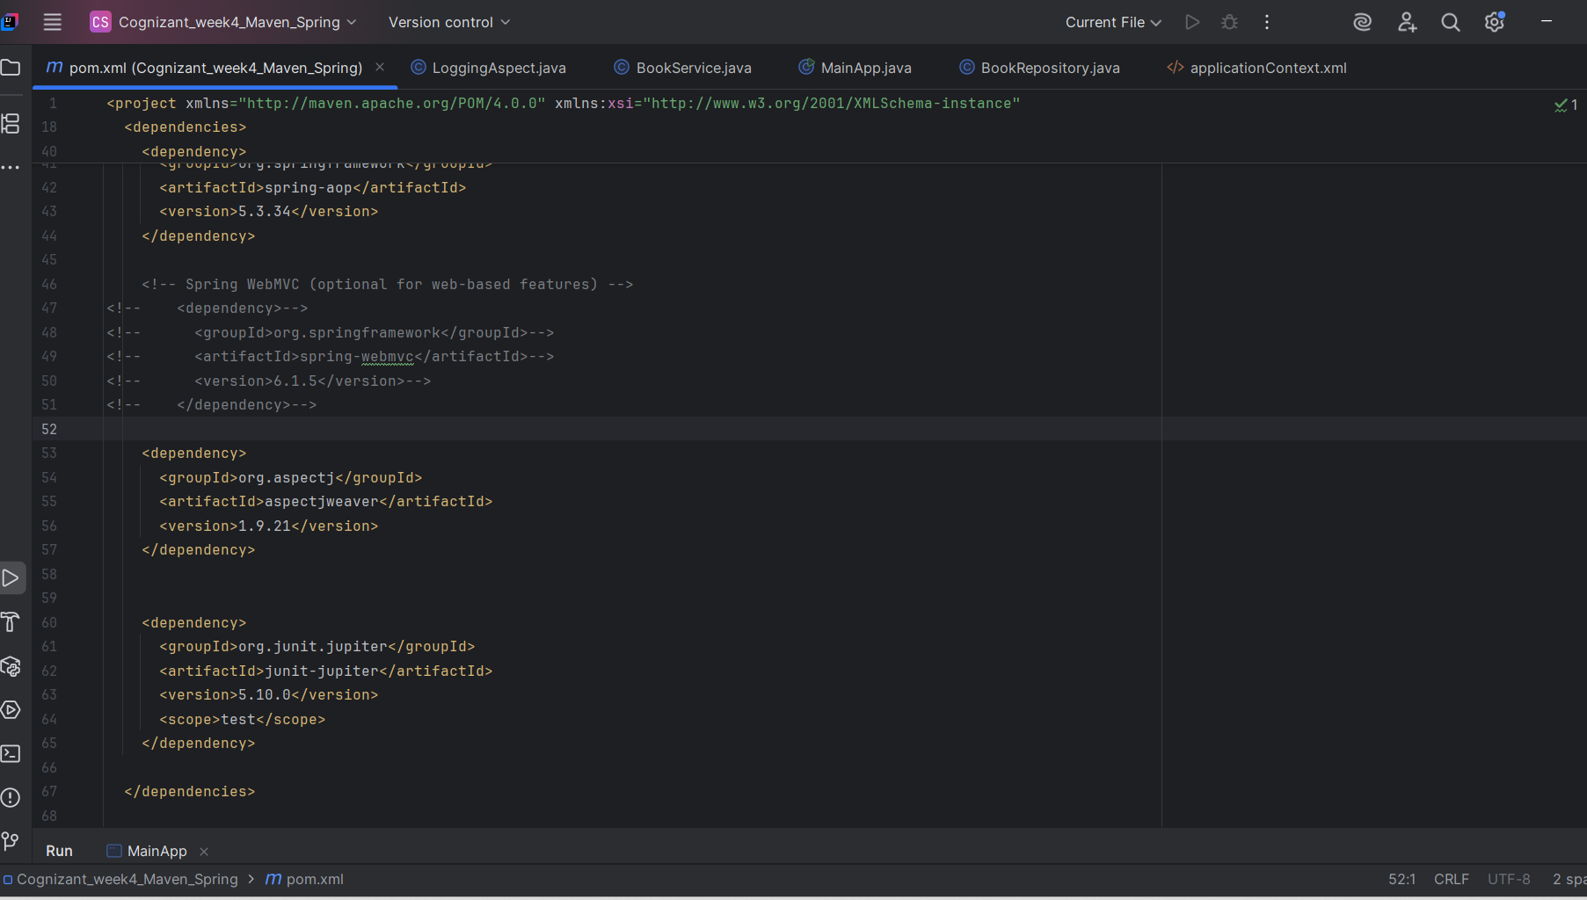

**Exercise 5: Configuring the Spring IoC Container**

**Scenario:**

The library management application requires a central configuration for beans and dependencies.

**Steps:**

1. **Create Spring Configuration File:**
   * Create an XML configuration file named **applicationContext.xml** in the **src/main/resources** directory.
   * Define beans for **BookService** and **BookRepository** in the XML file.
2. **Update the BookService Class:**
   * Ensure that the **BookService** class has a setter method for **BookRepository**.
3. **Run the Application:**
   * Create a main class to load the Spring context and test the configuration.

**Exercise 6: Configuring Beans with Annotations**

**Scenario:**

You need to simplify the configuration of beans in the library management application using annotations.

**Steps:**

1. **Enable Component Scanning:**
   * Update **applicationContext.xml** to include component scanning for the **com.library** package.
2. **Annotate Classes:**
   * Use **@Service** annotation for the **BookService** class.
   * Use **@Repository** annotation for the **BookRepository** class.
3. **Test the Configuration:**
   * Run the **LibraryManagementApplication** main class to verify the annotation-based configuration.

**Exercise 7: Implementing Constructor and Setter Injection**

**Scenario:**

The library management application requires both constructor and setter injection for better control over bean initialization.

**Steps:**

1. **Configure Constructor Injection:**
   * Update applicationContext.**xml** to configure constructor injection for **BookService**.
2. **Configure Setter Injection:**
   * Ensure that the **BookService** class has a setter method for **BookRepository** and configure it in **applicationContext.xml**.
3. **Test the Injection:**
   * Run the **LibraryManagementApplication** main class to verify both constructor and setter injection.

**Exercise 8: Implementing Basic AOP with Spring**

**Scenario:**

The library management application requires basic AOP functionality to separate cross-cutting concerns like logging and transaction management.

**Steps:**

1. **Define an Aspect:**
   * Create a package **com.library.aspect** and add a class **LoggingAspect**.
2. **Create Advice Methods:**
   * Define advice methods in **LoggingAspect** for logging before and after method execution.
3. **Configure the Aspect:**
   * Update **applicationContext.xml** to register the aspect and enable **AspectJ** auto-proxying.
4. **Test the Aspect:**
   * Run the **LibraryManagementApplication** main class to verify the AOP functionality.

**Exercise 9: Creating a Spring Boot Application**

**Scenario:**

You need to create a Spring Boot application for the library management system to simplify configuration and deployment.

**Steps:**

1. **Create a Spring Boot Project:**
   * Use **Spring Initializr** to create a new Spring Boot project named **LibraryManagement**.
2. **Add Dependencies:**
   * Include dependencies for **Spring Web, Spring Data JPA, and H2 Database**.
3. **Create Application Properties:**
   * Configure database connection properties in **application.properties**.
4. **Define Entities and Repositories:**
   * Create **Book** entity and **BookRepository** interface.
5. **Create a REST Controller:**
   * Create a **BookController** class to handle CRUD operations.
6. **Run the Application:**
   * Run the Spring Boot application and test the REST endpoints.